Alaska Fire Standards Council Fall Meeting
Agenda for September 29, 2024, at 9:00 am
On-site Council Meeting
Wasilla Fire Station 61
101 W Swanson, Wasilla AK, 99654
Zoom Participation Information
https://us06web.zoom.us/j/7816540128?omn=88423655005, Meeting ID: 781 654 0128
DRAFT Meeting Minutes

- Call to Order - 0911
- Roll Call
  - Brian Maas -Present
  - Dan Grimes – Present
  - Kevin Knowlton – Present
  - Rob Mathis – Present
  - Brian Long – Present
  - Dorianne Sprehe – Present
  - Ben Simonds – Present
  - Lloyd Nakano – Present
  - Matt Eckart - Present
  - Eric Shultz – Present
  - Virginia McMichael – Present
  - Stephanie Parker - Present
- Visitor Recognition
  - Robert Denard
  - Brady Fink
  - Craig Lewis
  - Mark Brauneis
  - Stephanie Russell
  - Ken Montero
  - Roy Moore
  - Todd Russell
  - Ian Miller
- Approval of Agenda
  - Grimes – Motion to approve agenda
  - Brian Long – 1st
  - Rob Mathis – 2nd
  - Grimes – Amendment of “Item F Best Practices under Old Business” for FESI Renewal and continuing correspondence with Interior Fire Chiefs Association.
    - No discussion
  - Agenda Approved with amendments made
- Approval of Minutes
  - Grimes – Motion to approve Spring 2024 Meeting in Juneau
  - Grimes – Amendment to Item 11 New Business Letter B proposal to remove renewal process for the Fire Emergency Service Instructor Standard and shorten practical to 5 minutes.
  - Brian Long – 1st
  - Rob Mathis – 2nd
  - Meeting Minutes Approved with amendments made
- Technical Advisory Committee- Progress Reports
NFPA 472/1072: Haz Mat – Tyler Bones
Parker spoke on behalf of Tyler Bones. 470 must go live December 31, 2024. Test bank, correlation sheets in process now and will be ready to go.
NFPA 1001: Fire Fighter – Rocky Jones
Parker spoke on behalf of Rocky Jones. 1010 is currently being worked on. Everything is moving forward.
NFPA 1002: Driver Operator – Todd Russell
Reorganization of 1001 to 1010. Will be meeting with AFSC. Needs a copy of 1010.
NFPA 1003: Airport Firefighter – Darcey Perry
No report. Reach out to Perry and confirm she still wants to do AFF.
NFPA 1005: Marine FF for Land Based Firefighter – Rob Mathis
Reached out to other states and got some information that will help with our process. Now just need to get the committee together.
NFPA 1006: Technical Rescuer – Don Werhonig
Will review and advise.

NFPA 1021: Fire Officer – Eric Schultz
Just took over and will be meeting with AFSC and Administrator to get caught up.
NFPA 1033: Fire Investigator – Bryan Crisp
No Report
NFPA 1035: Fire Life Safety Educator/YFSI – Kyle Green
Virginia McMichael reporting. They are making headway. Need Test bank and Correlation Sheets. Also requesting ProBoard Accreditation.
NFPA 1041: Fire & Emergency Services Instructor – Dan Grimes
FESI I is good to go. FESI II is almost ready, will be ready by end of October. FESI III is not there yet.
NFPA 1041: Live Fire Technician – Jason Buist
Parker to follow up with Jason and see where this is at and verify Jason is still heading this up.
NFPA 1407: AK Rapid Intervention Technician – Dan Grimes
Changes are easy but doesn’t have the time. Requesting help
NFPA 1521: Fire Department Safety Officer – Jake Bender
No Report
AK Rural Fire Protection Specialist – Ben Knowles
Ben Schultz has joined the division and will be the Lead on Rural Fire. Moving to have one name for the program, Rural Fire Program. Would like to take 12 Modules and have the ability to use for continuing education and have the ability to send a module to a department to work towards getting Rural Fire Cert. Will bring it to the Spring Meeting. We need more people.
Kevin Knowlton would like to help.

- Administrator’s Report
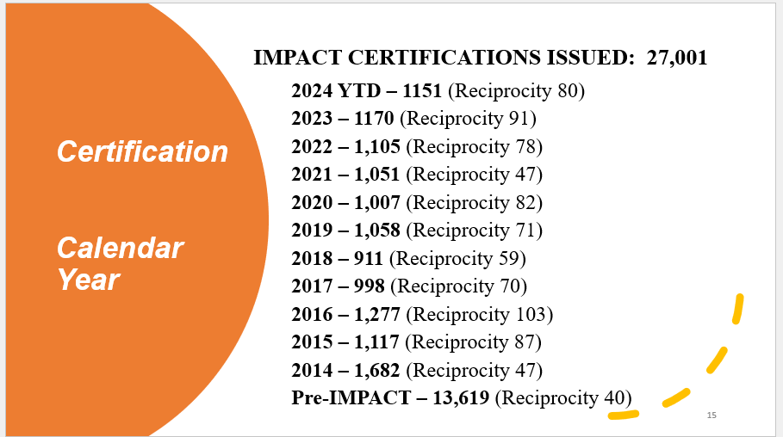
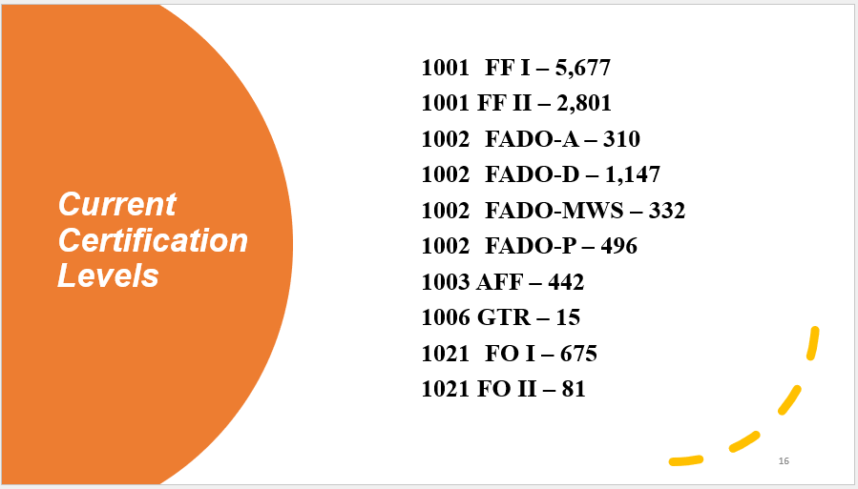

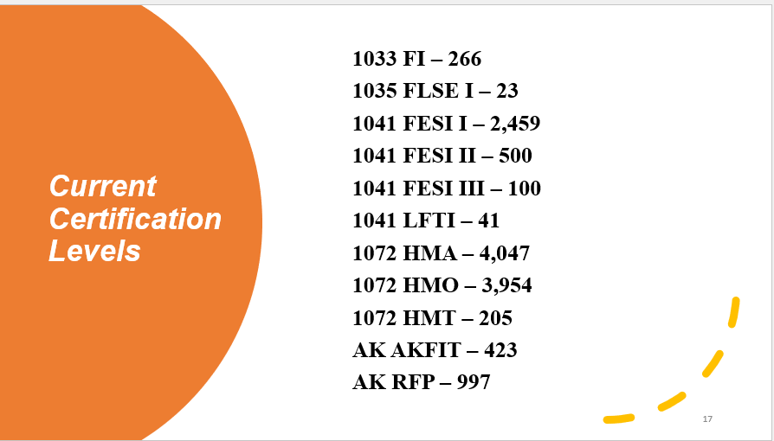

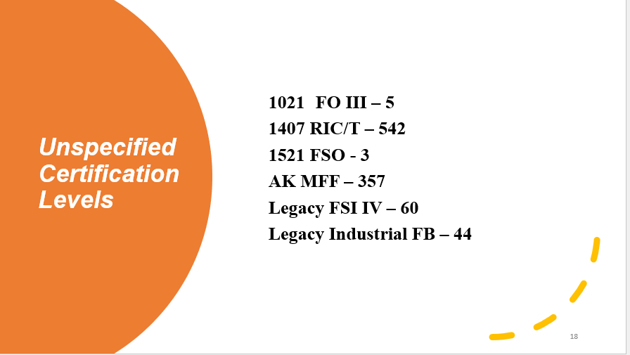

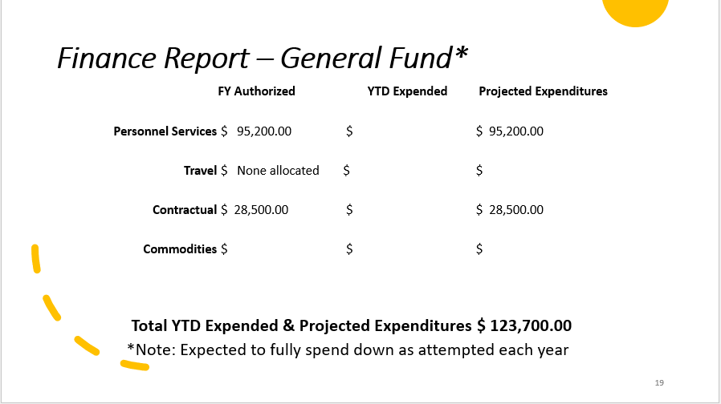

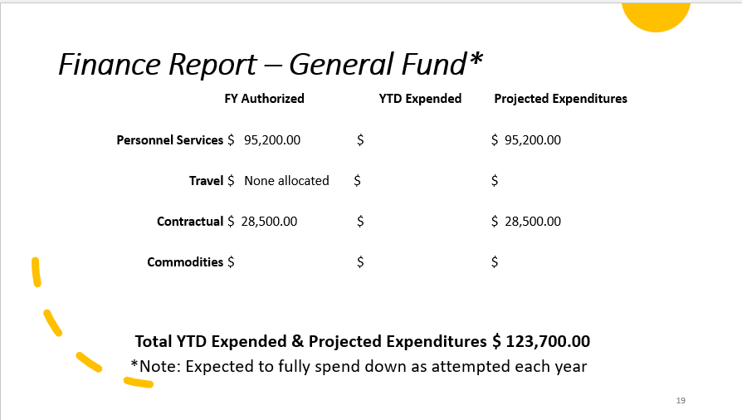

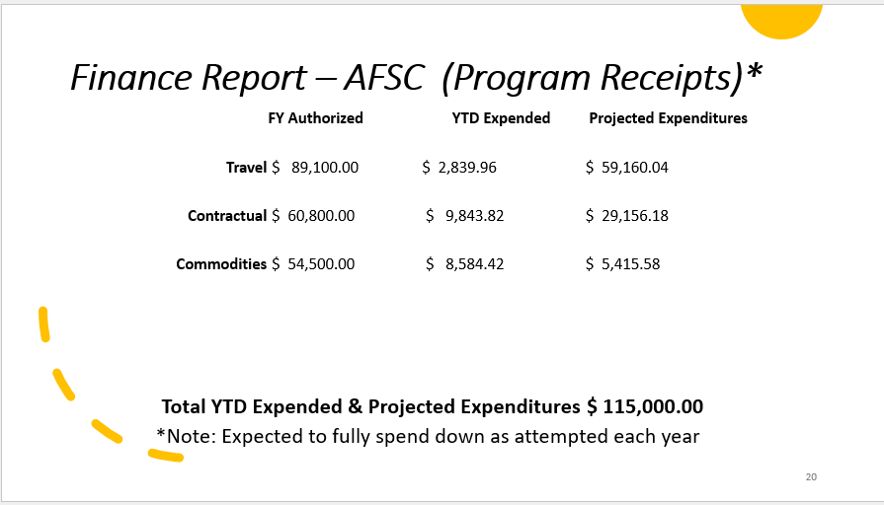

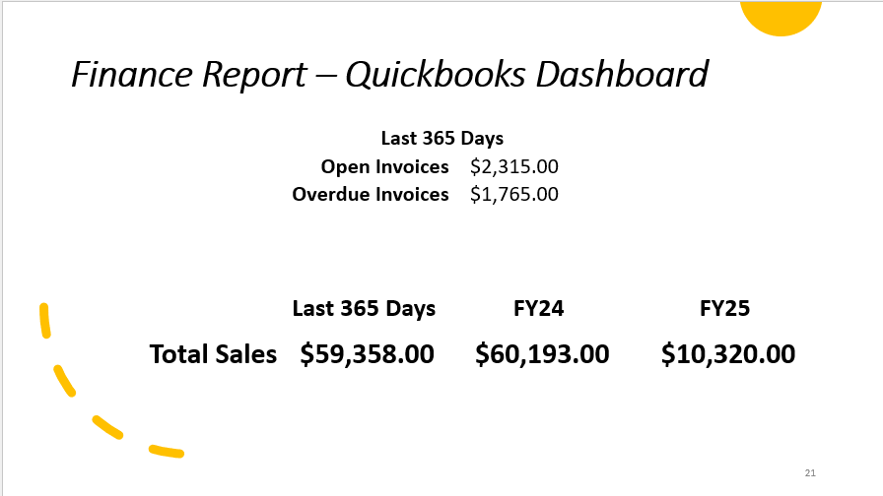

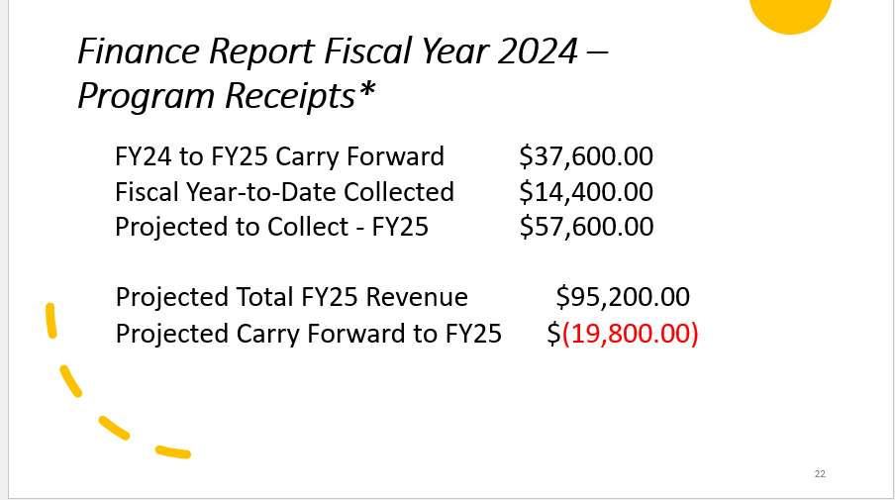

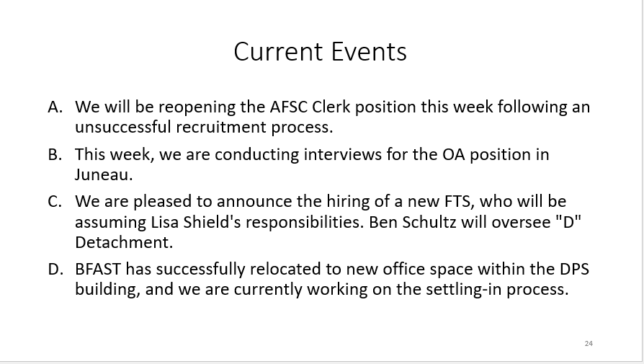

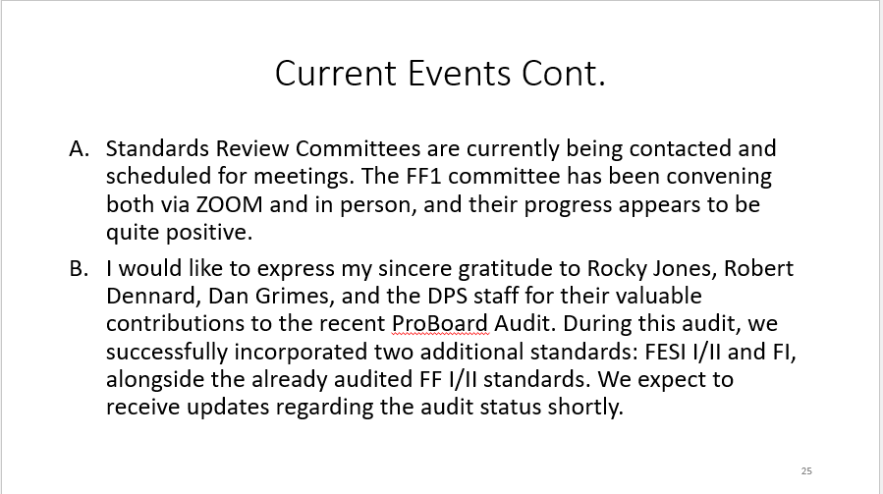

Break 1005
Reconvene 1016

- Public Comment Period
No Public Comment

- Association Reports
  - Alaska Fire Chief’s Association
    - Nothing to report
  - Alaska State Firefighters Association
    - Nothing to report
  - Alaska Professional Firefighters Association
    - Nothing to report

- Old Business
  - Rural Fire Protection – Parker
    - Dan Grimes – Motion to Discuss
    - Kevin Knowlton – 1st
    - Dan Grimes 2nd
      - Hans Nelson no longer with the Fire Service. Still need to fix test bank. Report desired changes at Spring 2025 Meeting.
Vote
      - Brian Maas – Yes
      - Dan Grimes – Yes
      - Kevin Knowlton – Yes
      - Rob Mathis – Yes
      - Brain Long – Yes
      - Virginia McMichael – Yes
      - Dorianne Sprehe – Yes
      - Lloyd Nakano _ Yes
      - Matt Echart – Yes
      - Ben Simmonds – Yes
      - Eric Schultz – Yes
Approved
  - Strategic & Operations Plan Review/Rewrite - Grimes
    - Virginia McMichael – Several Standards, some now under 1010, update these. Other sections may need to be combined.
    - Rob Mathis – Funding and Standards ongoing/or review as necessary.
    - Dan Grimes – Goal is to have an easy doc, easy to follow
    - Mathis – Request to Table until Spring and have meeting with Dan Grimes, Virginia McMichael.
    - Brian Long – 2nd
Vote
- Tyler Bones - Absent
- Brian Maas – Yes
- Dan Grimes -Yes
- Kevin Knowlton -Yes
- Rob Mathis – Yes
- Brain Long – Yes
- Virginia McMichael – Yes
- Dorianne Sprehe – Yes
- Ben Simonds – Yes
- Lloyd Nakano – Yes
- Matt Echart -Yes
- Eric Schultz – Yes

Approved

  - Legislative initiatives – Grimes
    - Dan Grimes – Funding for AFSC. Working to restore fulltime Administrator, separate from BFAST, and getting a 3rd person to help.
    - Dan Grimes – Governor’s office abolished several of Boards and Commissions in the Spring 2023. This is expected to happen again, and we need to be prepared.
    - Lloyd Nakano – Made a motion to change verbiage on Legislative 18.70.355 Powers to say “Shall instead of May” employ.
    - Kevin Knowlton- 2nd Table ******Look at this****
Vote
Tyler Bones - Absent
Brian Maas – Yes
Dan Grimes – Yes
Kevin Knowlton -Yes
Rob Mathis – Yes
Brian Long – Yes
Virginia McMichael -Yes
Dorianne Sprehe -Yes
Ben Simonds – Yes
Lloyd Nakano -Yes
Matt Echart – Yes
Eric Shultz – Yes
Tabled

Break for Lunch 1143
Reconvened 1236

Grimes – Motion to table this and requested a Special Meeting no longer than 60 days out (before November 28, 2024) to put purposed language together.
Kevin Knowlton- 2nd

Vote
Tyler Bones – Absent
Brian Maas – Yes
Dan Grimes – Yes
Kevin Knowlton – Yes
Rob Mathis – Yes
Brian Long – Yes
Virginia McMichael – Yes
Dorianne Sprehe – Yes
Ben Simonds – Yes
Lloyd Nakano – Yes
Matt Echart -Yes
Eric Schultz – Yes
Tabled

  - Number of times someone can test – Parker
Mathis – Motioned to change language in CPM 9.2.1 “After three total attempts to pass the written exam, the request for additional examinations must be in writing and must include a letter from the Training Officer or the Fire Chief describing additional remedial training completed to assist the candidate. If a candidate fails a fourth written examination, the AFSC recommends that the candidate complete the entire training course. AFSC staff will review additional retest requests on a case-by-case basis. The candidate has two years following successful course completion to obtain the remedial training and successfully complete the written examination.” To “After three total attempts to pass the written/practical exam, the request for a fourth examination must be in writing and must include a letter from the Training Officer or the Fire Chief describing additional remedial training completed to assist the candidate. If a candidate fails a fourth written/practical examination, the AFSC requires that the candidate complete the entire training course. The candidate has two years following successful course completion to obtain the remedial training and successfully complete the written/practical examination.”
Eckart – 2nd

Vote:
Bones – Absent
Maas – Yes
Grimes – Yes
Knowlton – Yes
Mathis – Yes
Long – Yes
McMichael – Yes
Sprehe – Yes
Simonds – Yes
Nakano – Yes
Eckart – Yes
Schutlz – Yes
Passed

Break @ 1348
Reconvened @ 1402

  - Test Bank Changes – Parker
Parker – Would like to table any changes to the test banks. We would like to focus on an online testing and records management platform.
Knowlton – Motion to table test bank changes.
Mathis – 2nd

Vote:
Bones – Yes
Maas – Yes
Grimes – Yes
Knowlton – Yes
Mathis – Yes
Long – Yes
McMichael – Yes
Sprehe – Yes
Simonds – Yes
Nakano – Yes
Eckart – Yes
Schultz – Yes
Passed

  - FESI Renewal Process – Best Practices Report – Grimes

- New Business ***********Statuary language*********
  - Terms Expiring on 12/31/2024
    - Sprehe, Dorianne (Wrangell), Vice Chair, Public/Under 2500 Residents
      - Dorianne stated that she will not be seeking reappointment for her seat nor will she be accepting nominations for Chair.
Sprehe – Nominates Ben Simonds as Vice Chair
Grimes – 2nd
Vote:
Bones – Yes
Maas – Yes
Grimes – Yes
Knowlton – Yes
Mathis – Yes
Long – Yes
Sprehe – Yes
Simonds – Yes
Nakano – Yes
Eckart – Yes
Schultz – Yes
McMichael – Yes
Passed
  - 1010 – Support Firefighter

- Action Items

- 472/470- Bones and team working on it getting it out on December 31, 2024
- 1003 – Parker to reach out to Darcey Perry to verify she is still wanting to do ARFF
- 1006- Werhornig will look it over and see what is needed
- 1005 – Committee to get together and go over what is needed
- 1010- Parker to make everyone aware of the Support Firefighter and get copies of it to SME’s
- 1041- Grimes to have FESI II ready in 30 days
- 1033- Parker to get information to Don Werhornig
- 1035 – Parker to get test banks and correlations
- 1041- Parker to reach out to Jason Diorec about the standard
- 1407- Looking for help, need SME’s
- AFSC Office- Update website with map of Detachments
- Rural Fire- Parker to reach out to committee and have desired changes presented no later than 60 days, November 28th, 2024.
- Sprehe – Write letter to Chief Coon advising process to make a formal complaint.
- Parker- Request a Special Meeting when ready to move forward with Online Testing/Records Management and ability for the Chief’s to take over CO testing.
- Everyone- Talk to your constituents about verbiage change for AS. 18.70.355

- Future Agenda Items
Future Meeting Dates
  - 2025 Spring Meeting – Juneau: January 27th, 2025
  - 2025 Leadership Summit – Juneau: January 27- 31st, 2025
Vote:
Bones – Absent
Maas – Absent
Grimes – Yes
Knowlton – Yes
Mathis – Yes
Long – Yes
McMichael – Yes
Sprehe – Yes
Simonds – Yes
Nakano – Yes
Eckart – Yes
Schultz – Yes
Passed

- Good of the Order
Nakano- Gave a huge shout out to BFAST Team for their hard work and getting us through the ProBoard Audit.

Grimes – Motion to adjourn
Long – 1st
Schultz – 2nd

Adjourned 1646

