Alaska Fire Standards Council Spring Meeting

Agenda for January 27,2025, at 9:00 am

***On-site Council Meeting***

Baranof Hotel Juneau

127 N Franklin St, Juneau, AK 99801

***Zoom Participation Information***

[**https://us06web.zoom.us/j/89704697705**](https://us06web.zoom.us/j/89704697705) **Meeting ID # 897 0469 7705**

**DRAFT Final Meeting Minutes**

1. Call to Order @ 0907
2. Roll Call

Brian Maas – Present

Brian Long – Present

Dan Grimes – Present

Rob Mathis – Present

Ben Simonds – Present

Matt Eckart – Present

Virginia McMichael – Present

Eric Schultz – Present

Kevin Knowlton - Excused

Lloyd Nakano – Excused

Stephanie Parker – Present

1. Visitor Recognition

Mark Brauneis

1. Approval of Agenda

1st Mathis

2nd Schultz

Mathis Amend “Fall” to Spring”

1st Mathis

2nd Schultz

Vote:

Maas-Yes Grimes - Yes

Long- Yes Mathis – Yes

Simonds -Yes Eckart – Yes

McMichael -Yes Schultz – Yes

APPROVED

1. Approval of Minutes

1st Schultz

2nd Simonds

Grimes - Discussion

Grimes Amend, ~~recall vote for changes~~

* NFPA 1035 to 1030
* Recognition of Service needs to be added after “Election of Officers”
* Future Meeting to say “Fall” instead of “Spring”

1st Schultz

2nd Simonds

Vote:

Maas-Yes Grimes - Yes

Long- Yes Mathis – Yes

Simonds -Yes Eckart – Yes

McMichael -Yes Schultz – Yes

APPROVED

1. Technical Advisory Committee- Progress Reports

NFPA 472/1072: Haz Mat – Tyler Bones

Bones - NFPA 470 is live as of December 31, 2024, just waiting on IFSAC and ProBoard approval for seal and will implement 6th Edition of Awareness and Operations, and 3rd Edition of Technical.

NFPA 1010/1001: Fire Fighter – Rocky Jones

Stephanie Parker for Rocky Jones, no new changes, working on finalizing skill sheets, Support Firefighter passed and would like it to added to this committee.

NFPA 1010/1002: Driver Operator – Todd Russell

Stephanie Russell for Todd Russell – No changes at this time.

NFPA 1010/1003: Airport Firefighter – Darcey Perry

Perry – Verbiage is the same as 1003, skill sheets are being updated and will be to the AFSC office at end of the month.

NFPA 1010/1005: Marine FF for Land Based Firefighter – Rob Mathis

Mathis – Reached out to other agencies, formatting skill sheets, there are no test banks from J&B or IFTSA will work on creating a test bank.

NFPA 1006: Technical Rescuer – Don Werhonig

Grimes for Werhornig – Rescue can move forward with Rope, and Confined Spaces. ~~Dan~~ Don will email AFSC office.

NFPA 1021: Fire Officer – Eric Schultz

Schultz – Received IFSTA test banks, waiting on IFSTA Hard Book

NFPA 1033: Fire Investigator – Bryan Crisp

Crisp – Everything is still good. Waiting on ProBoard to approve for seal. Fire Investigator Conference in Anchorage this year March 24 – 28th, 2025

NFPA 1030: Fire Life Safety Educator/YFSI – Kyle Green

Green – Ready to move forward for accreditation. Waiting on test bank to come out in a few months.

NFPA 1041: Fire & Emergency Services Instructor – Dan Grimes

Grimes – FESI II was ready to go early November, FESI III needs work and committee help

Mathis – Will be on the committee

Schultz – Will be on the committee

NFPA 1041: Live Fire Technician – Jason Buist

Parker – We need a new committee lead

Schultz – Will take the lead

NFPA 1407: AK Rapid Intervention Technician – Dan Grimes

Grimes – Requesting AFSC to email documents that were on website to move forward. Also looking for committee members.

Eckart – Wil be on the committee

NFPA 1521: Fire Department Safety Officer – Tyler Bones

Grimes for Bones – Need committee members

AK Rural Fire Protection Specialist – Ben Knowles

Parker – We need a new Rural Lead and committee members

Mathis – Will take the lead

BREAK: 1001

RETURN: 1011

1. Administrator’s Report

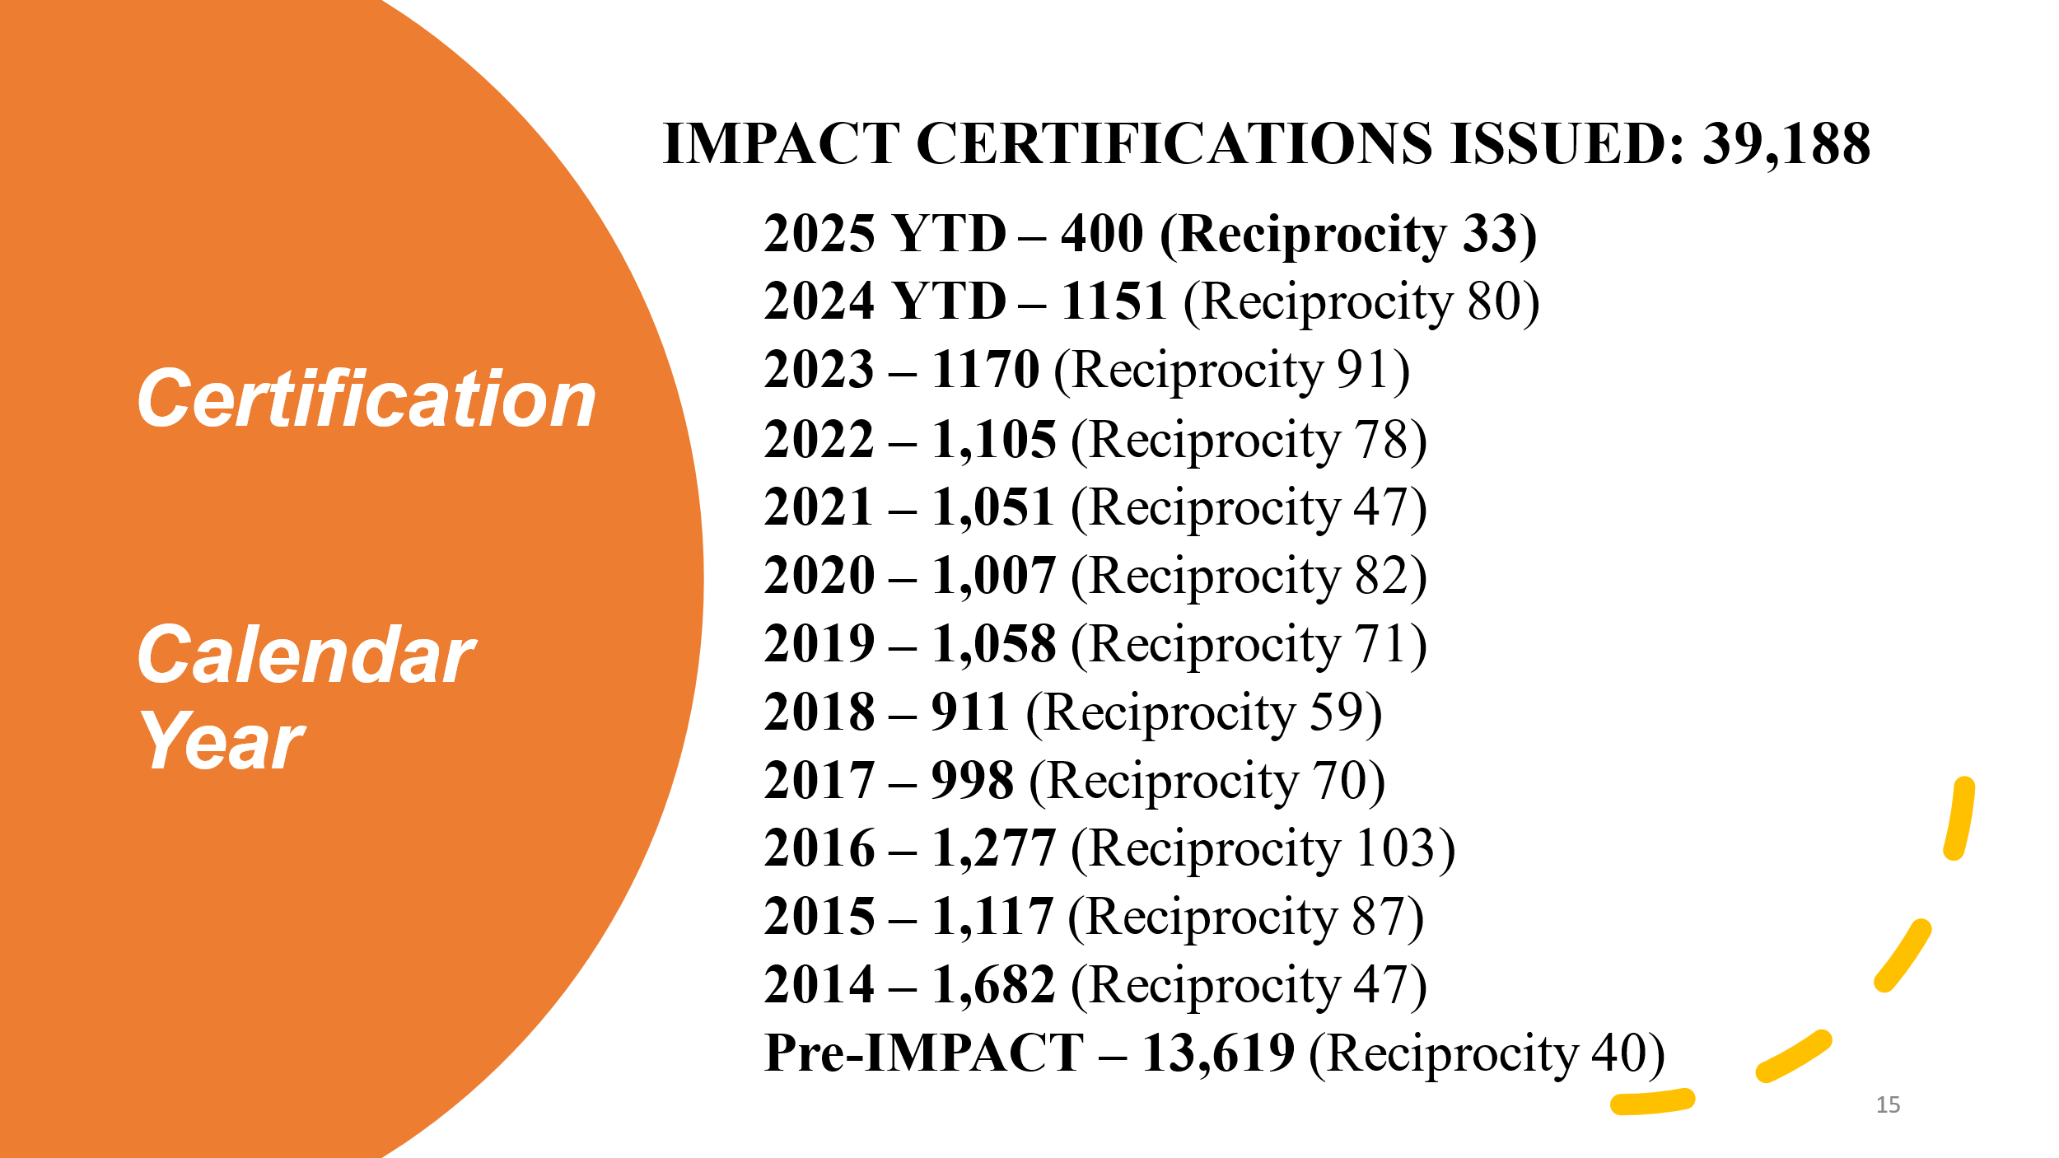

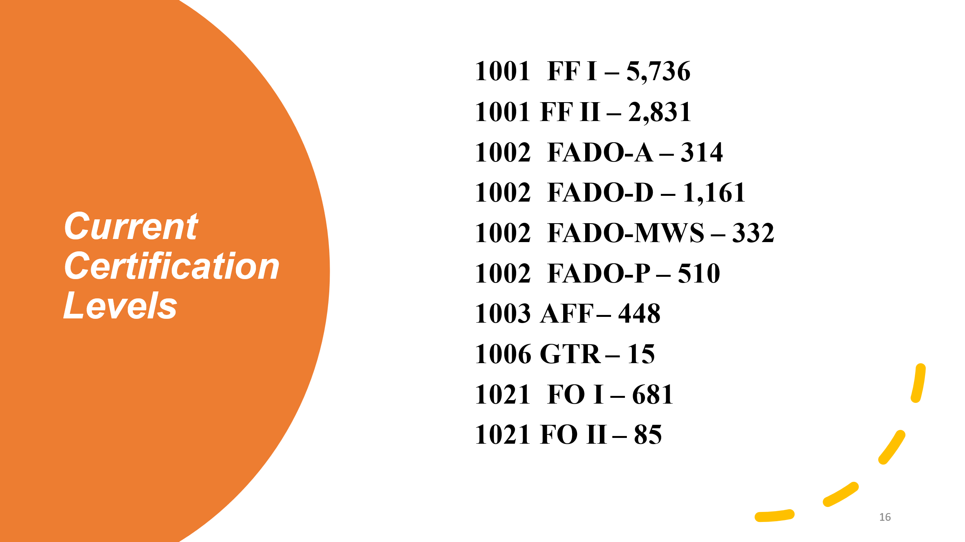

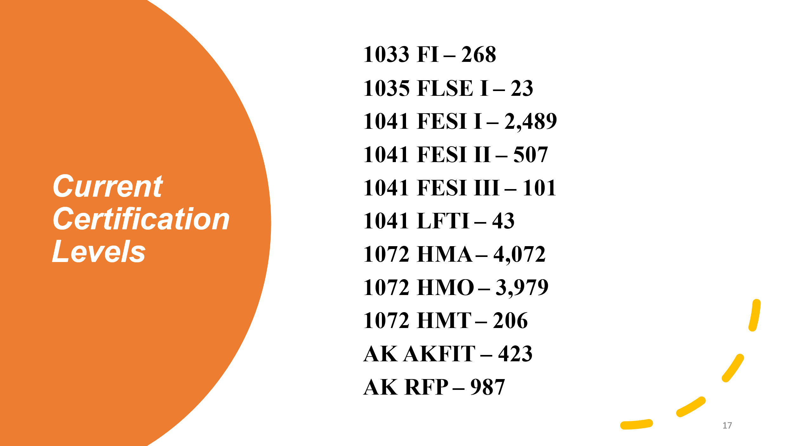

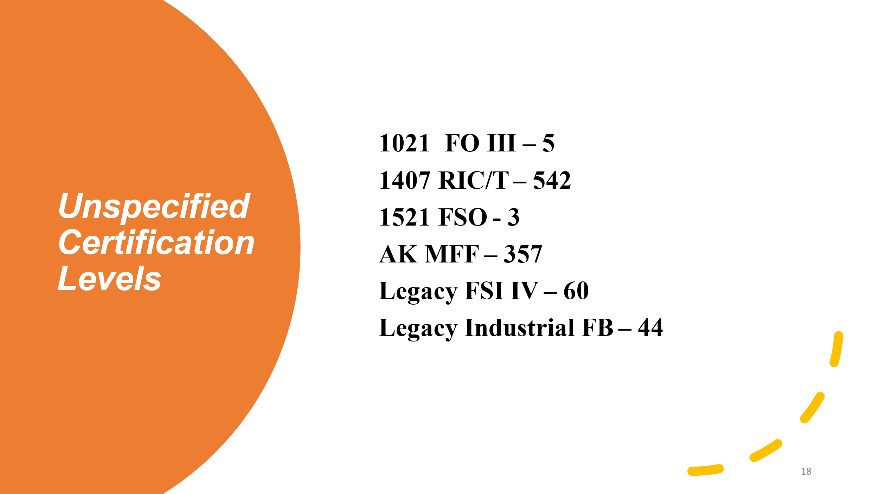

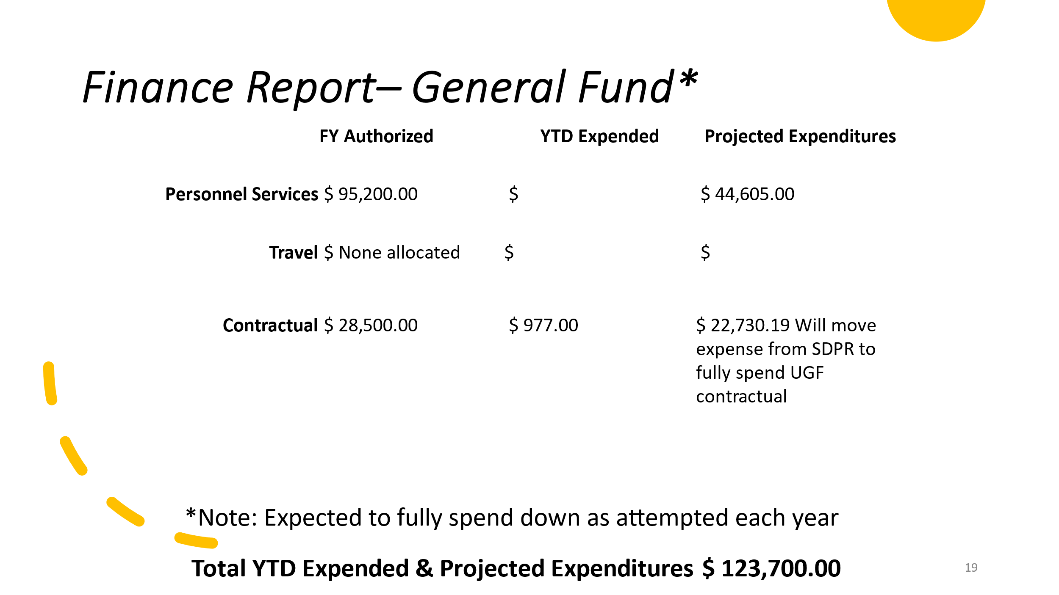

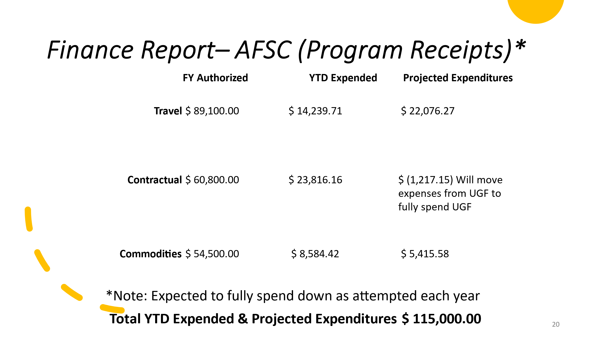

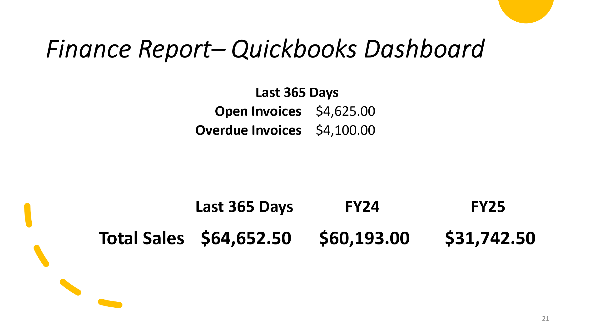

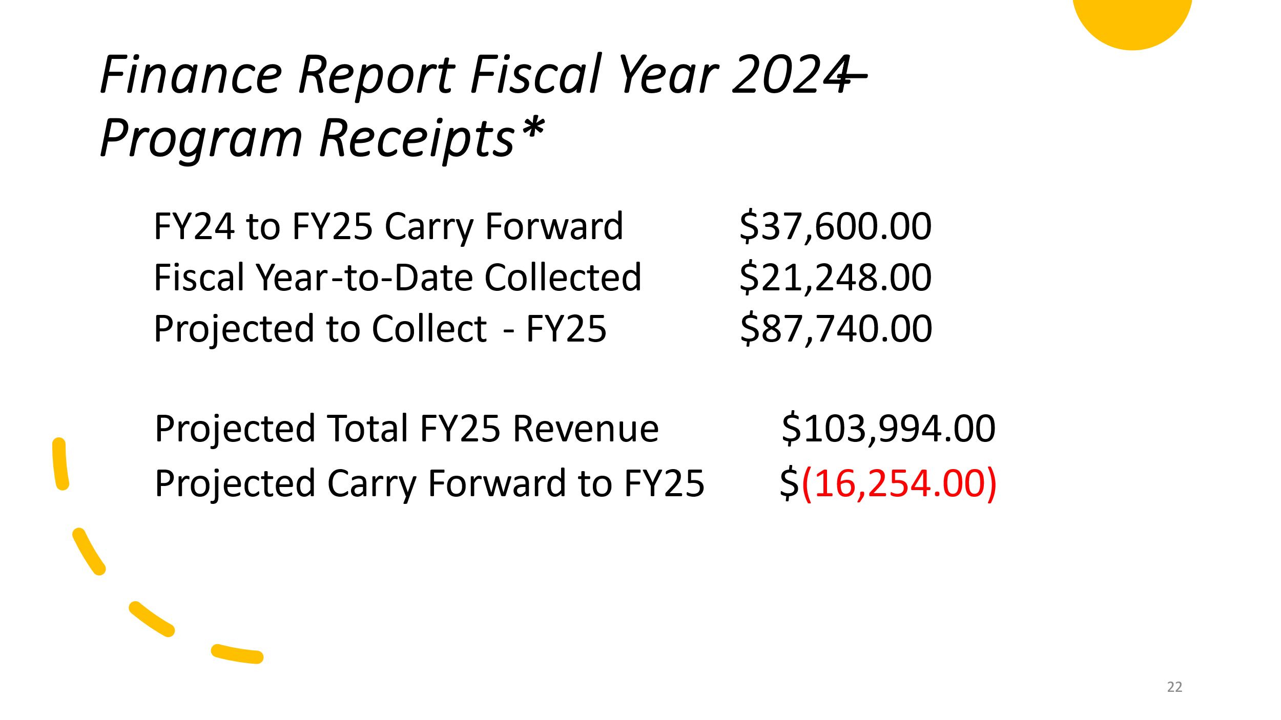

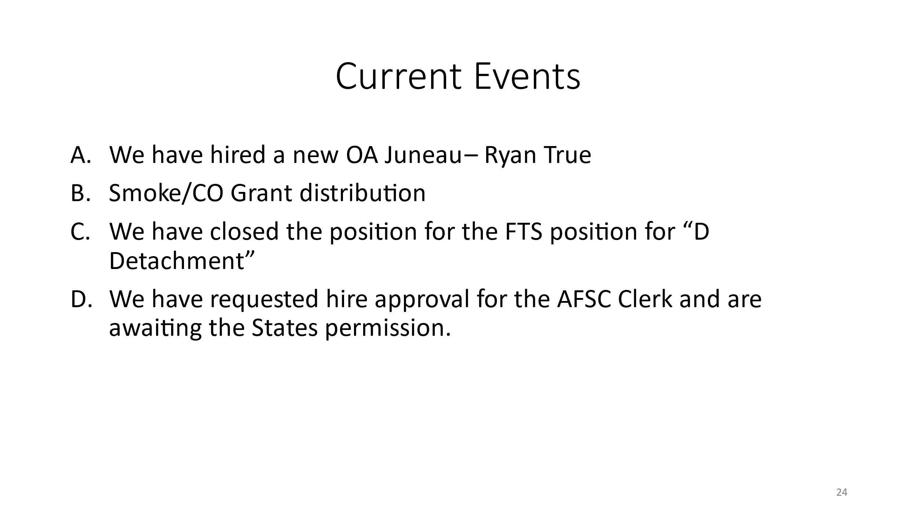

Grimes – Would like to request that Proctored tests have shipping slip sent with tests for returns like CO testing process.

Parker – Will do.

1. Public Comment Period

None

1. Association Reports
   1. Alaska Fire Chief’s Association

Grimes- ~~Nothing yet,~~ Supporting Initiatives for Staffing and Funding. Not in favor of statutory language change to 18.70.355 “May” to “Shall” ~~employ~~ regarding certifications as requested in last meeting. Will be meeting with ~~legislation~~ Legislators this week.

* 1. Alaska State Firefighters Association

Maas – No reports at this time. EMS working on making TIMS class a requirement.

* 1. Alaska Professional Firefighters Association

Simonds – Would like to know where online testing stands, will be speaking with ~~legislation~~ Legislators about retirement, and willing to speak on anything we want and issues at hand.

1. Old Business 
   1. Reconsideration of Statuary language change – Mathis
      1. A.S. 18.70.355 Did not pass and would like to propose new language:

Mathis – Motion to change verbiage as shown

McMichael – 2nd

Grimes – Open for discussion

Grimes – This is a “NO GO” from constituency. 1st issue is they don’t like being made to get certs. 2nd issue the original is very cleat and this doesn’t make it clear if this is a “must” or “not”. No interest in making this mandatory.

Mathis – Request to table this and bring it back to constituency with new verbiage?

Grimes – Constituency says, “No”. We need to move 18.70.350 through and this will hold up that process.

Mathis – Requesting a vote to re-consider this as proposed language change at a later date after taking it back to constituency.

Grimes – Would like to move forward with only 18.70.350 and at a later date have a group of people come together and come up with new verbiage and fresh eyes.

Grimes – Call for vote

Maas – Yes Long – No

Grimes – No Mathis – Yes

Simonds – No Eckart – Yes

Schultz – No McMichael – Yes

DOES NOT PASS

BREAK: 1130

RETURNED: 1146

* 1. Online Testing and Records Management – Parker

Mark Brauneis for Parker – We will be moving forward with ACADIS/Vector Solutions with on-line testing and records management. We are waiting on our I.T. steering committee and DFLS-BFAST will be paying for initial setup.

Grimes – Requests that Administrator Parker please keep Chiefs and AFSC apprised of the progress monthly.

Parker – Agrees and will send monthly updates to AFSC Council, AFCA, and ListServe.

* 1. 1010 Support Firefighter – Standing Committee – Parker

Parker – looking for committee lead to help

Mathis – Will assist

* 1. Verbiage to testing – Eric Schultz/Parker

Schultz – Verbiage for both written and practical will state. “3 attempts on the initial testing, remedial training will occur, and final attempt on next test”. CPM will be updated to reflect changes.

1. New Business
2. Legislative initiatives – Grimes
   1. A.S. 18.70.350 Powers

Grimes – Will seek a bill, need a sponsor and would like a group of people to speak and bring it back to AFSC.

1. Election of officers
   1. Chair – Grimes

Grimes – Will NOT be seeking re-election nor accepting position

~~EXCEPTION of~~ Request for NOMINATIONS

1st Grimes – Nominate Ben Simonds

2nd Schultz

Ben Simonds – Will accept

VOTE

Maas -Yes Long – Yes

Grimes – Yes Mathis – Yes

Simonds – Yes Eckart – Yes

Schultz – Yes McMichael – Yes

APPROVED

* 1. Vice Chair – for 6 months will renew in Fall

~~EXCEPTION of~~ Request for NOMINATIONS

1st Simonds – Eric Schultz

2nd Grimes

1st Schultz – Rob Mathis

2nd Simonds

Simonds – Motions to do an open ballot

2nd Eckart

Grimes – Voice Vote Passed

Maas – Mathis Long – Mathis

Grimes – Mathis Mathis – Mathis

Simonds – Schultz Eckart – Schultz

Schultz – Schultz McMichael – Mathis

MATHIS new Vice Chair

1. Recognition of Service

Grimes – Dorriane Sprehe for a Service Plaque

1. Action Items

Parker – Fix Agenda and Meeting Minutes

Perry – Get skill sheets to AFSC office by end of month

Mathis – Get with AFSC and committee to make test bank for Marine

Grimes – Email 1006 to AFSC

Parker – Get IFSTA1021 Handbook to Schultz

Parker – Get Test bank for 1030 to Green when it comes out

Grimes – Meet with Mathis and Schultz for FESI III

Parker – Update 1041 as Schultz as Lead

Parker – Email 1407 documents to Grimes

Parker – Update Rural Fire Leas and Mathis

NFPA 1521 – NEEDS COMMITTEE MEMBERS

Parker – Update Proctored test return labels to be like CO tests

Parker – Keep communications open on ACADIS/Vector Solutions

Parker – Get Service Plaque out to Dorriane Sprehe

Parker – Update Directives and CPM to reflect verbiage changes

Parker – Update AFSC Website to reflect AFSC Members

1. Future Agenda Items
2. Future Meeting Dates
   1. 2025 Fall meeting,

September 28th, 2025, Sitka, Alaska

1. Good of the Order

Simonds – Thanking Dan Grimes for his many years of service, and for the vote of confidence.

Grimes – Thanking everyone and it has been a pleasure working with you all. He will be leaving December 1, 2025, and will guide Simonds and Mathis for the Fall meeting.

Grimes – Motion to adjourn

Mathis – 2nd

Adjourned 1252