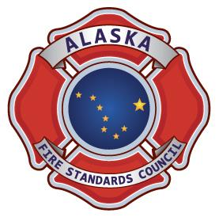
ALASKA FIRE AND EMERGENCY SERVICES INSTRUCTOR II TRAINING RECORD
ALASKA FIRE STANDARDS  COUNCIL  FIRE AND EMERGENCY SERVICES  INSTRUCTOR II  TRAINING RECORD | Candidate Name: | Candidate Signature:
 | Training Officer: | Completion  Date:

NFPA 1041  2019 | DESCRIPTION | Know-  ledge Req. | Review Date (Knowledge) | Skill Req.  (AFSC Sheet #) | Evaluation Date  (Skills) | Notes | Trng Officer/  Instr. Initials
5.2 | Program Management
5.2.2 | Assign instructional sessions | *YES |  | FSI II- 1
5.2.3 | Recommend budget needs | *YES |  | FSI II- 2
5.2.4 | Gather training resources | *YES |  | FSI II- 3
5.2.5 | Manage training record keeping | *YES |  | FSI II- 4
5.2.6 | Evaluate instructors | *YES |  | FSI II- 5
5.3 | Instructional Development
5.3.2 | Create a lesson plan | *YES |  | FSI II- 6
5.4 | Instructional Delivery
5.4.2 | Conduct a class using a lesson plan that the instructor has prepared and that involves the utilization of multiple teaching methods and techniques | *YES |  | FSI II- 7
5.4.3 | Supervise other instructors and students during training | *YES |  | FSI II- 8
5.5 | Evaluation and Testing
5.5.2 | Develop student evaluation instruments | *YES |  | FSI II- 9
5.5.3 | Develop a class evaluation instrument | *YES |  | FSI II- 10

ALASKA FIRE STANDARDS COUNCIL FIRE AND EMERGENCY SERVICES INSTRUCTOR II CERTIFICATION REQUIREMENTS
DESCRIPTION | Review Date (Verified) | Notes | Chief Officer/ Supervisor Initial
Certified Fire Service Instructor- Verify current AFSC FESI I certificate.
*Denotes knowledge comprehension requirement for written component of certification examination
State of Alaska Fire Standards Council policy requires that all individuals are at least 18 years of age to be eligible for fire service certification

AFSC FSI2TR NFPA 1041 2019 v3 12 2024 Page 1 of 1

